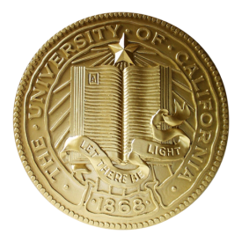**Astronomy 84: Black Holes**

***Science and People***

**Discussion 5.1 Fall 2017**

The story of Subrahmanyan Chandrasekhar and his work to understand white dwarf stars is not uncommon in science: a junior scientist makes a bold proposal only to have it shot down by a senior scientist (and often more than one). Chandrasekhar was one of the great astophysicists of the 20th century. Many of the senior scientists of his day recognized the importance of what he had done to calculate the size of white dwarf stars from first principles. The calculation of what we all call the Chandrasekhar radius of a dwarf star earned him the 1983 Nobel Prize in Physics.

For Wednesday’s discussion, your group should do some background research on other contributions that Chandraskhar made after he moved away from the white dwarf research in 1939 and present some of his other work to the class. The internet is a ready source of information, especially Wikipedia (but use many other sources as well). Think about his interactions with Eddington and decide whether these interactions helped or hindered science. Did Eddington benefit from these interactions by successfully defending a position or idea he held dear? What do you think the effect was on Chandrasekhar’s work and career?

If you were Chandrasekhar, what do you think your reaction to Eddington would have been? What lessons might we take away from this story that guide us in the way we see science as a human activity? Do you think science has similar issues with interaction among its practicing members today?